mysql> show databases;

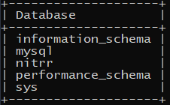

mysql> use nitrr;



mysql> show tables;

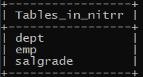

mysql> select *from emp;

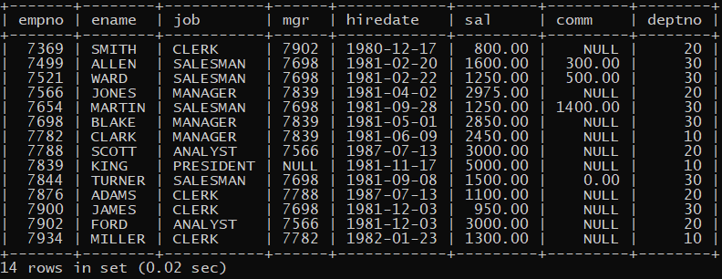

mysql> select *from dept;

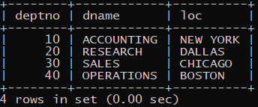

mysql> select *from salgrade;

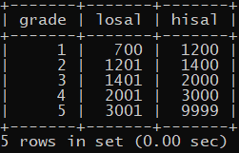

mysql> describe dept;

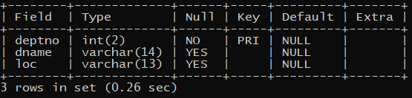

mysql> describe emp;

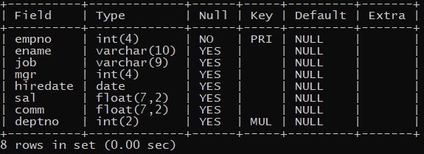

mysql> describe salgrade;

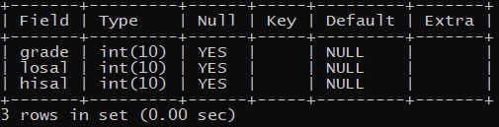

mysql> select*from emp where sal between 1000 and 3000;

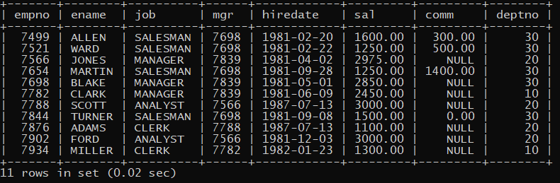

mysql> select ename,sal from emp;

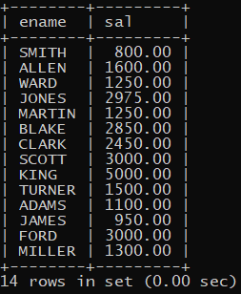

mysql> select ename,sal from emp order by ename;

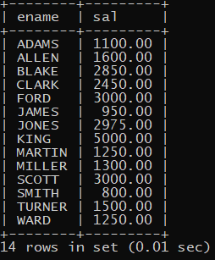

mysql> select ename,deptno from emp where deptno = 10 or 30;

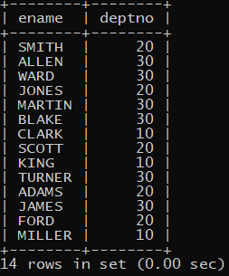

mysql> select ename from emp where ename like "S%";

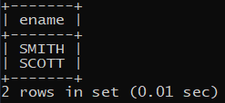

mysql> select ename from emp where ename like "____";

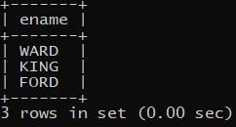

mysql> select ename from emp where ename like "%L";



mysql> select ename from emp where mgr is not null;

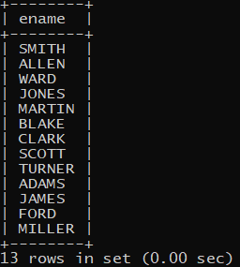

mysql> select ename from emp where mgr is null;

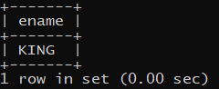

mysql> select sal+COALESCE(comm,0) as "total salary " from emp;

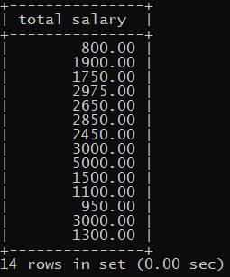

mysql> select ename,sal*12 as"annual salary" from emp;

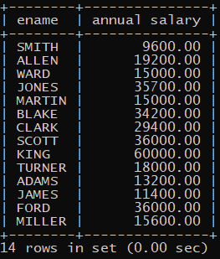

mysql> select ename from emp where year(hiredate)="1991";



mysql> select concat(ename," HAS HELD THE POSITION OF ",job," IN DEPATRMENT ",deptno," SINCE ",hiredate," AND EARNS ",sal) from emp;

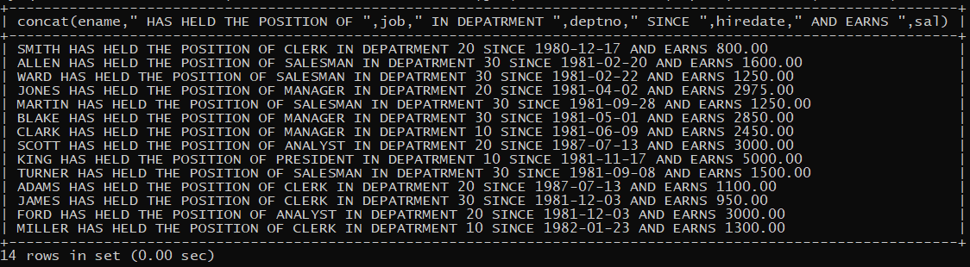

mysql> select distinct(job) from emp;

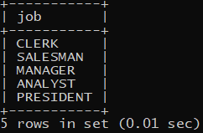

mysql> select 12*(sal+100) from emp;

